

**Hatherley Infant School – Story of Improvement**

Updated “Food and Drinks” policy to reflect work carried out to improve understanding. **(May)**

It was clear that teaching and learning in our school needed to focus on sugars in drinks in the first instance.  
Lesson input during **January and February,** includingwhole school assemblies.

Questionnaires were issued to all classes in school to ascertain the children’s favourite drinks and their level of understanding of why the school has a water only policy at lunchtimes.  
The results showed that of 153 children questioned, only 61 chose to drink water and only 67 were able to explain why water is the only choice at lunch in our school! **(November)**

**Objectives**Areas for development were identified as a result of parents’ questions regarding the food and drink encouraged at school. This was particularly true for new reception parents.  
It was identified that there was a need to educate both children and parents in our school about hidden and added sugars in food and drinks. **(October)**

Planned “Sugar Shockers” workshop for parents during Healthy Week in early **July**

Questionnaire re-issued to measure improvement in knowledge and understanding of the benefits of drinking and eating less sugar. 46 more children now drink water happily at lunchtime and 51 more children able to explain why we drink water. **(April)**

Whole school display in the hall with all classes contributing **(Feb/March)**

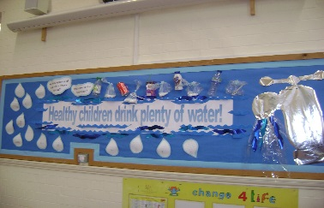

Healthy Lunchbox Guidance paper  
for parents updated to reflect new learning. **(April)**

PSHE and PE subject leaders attended a “Health, Wellbeing and Active Lifestyles” course which included a “Shocking Sugars” portion. Feedback to staff at staff meeting. **(March)**

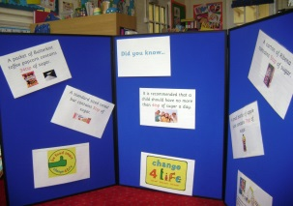

At Parents’ Evening a display of “Sugar Shockers” was produced and put in the school hall. Parents were encouraged to sign up for a parents’ workshop – to gauge the level of interest. **(March)**